**Vocabulary**

**Unit 7: Antebellum (Pre-Civil War)**

**(1840-1860)**

**1732**

Essential Questions

**slavery**

**antebellum**

**civil war**

**slave codes**

**class structure**

**state’s rights**

**sectionalism**

**nullification**

**tariffs**

**slave state**

**free state**

**free soilers**

**proslavery**

**popular sovereignty**

**abolitionists**

**secession (secede)**

**territory**

**election**

**presidential candidate**

**electoral college**

**popular vote**

**electoral vote**

**party platform**

**annex**

**border states**

**emancipation**

People and Places

**Eli Whitney**

**Dred Scott**

**Alexander Stephens**

**Abraham Lincoln**

**Stephen Douglas**

**John Breckinridge**

**Henry Clay**

**Joseph E. Brown**

**Milledgeville**

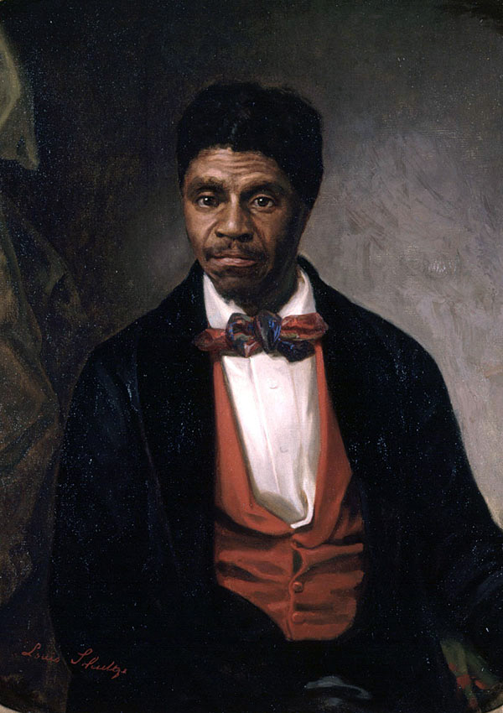

* **What events led to the cause of the Civil War?**
* **Slavery**
* **State’s rights**
* **Nullification**
* **Missouri Compromise**
* **Compromise of 1850**
* **Georgia Platform**
* **Kansas-Nebraska Act**
* **Dred Scott Decision**
* **Election of 1860**
* **Debate of secession**
* **Alexander Stephens**

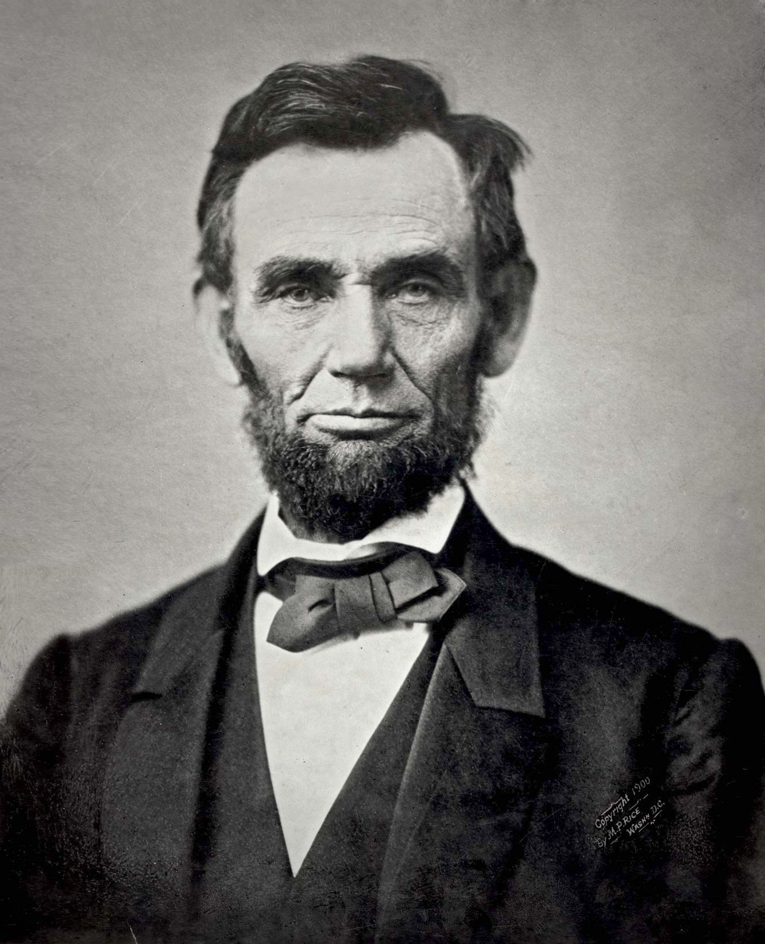

GPS Standards

**SS8H6, SS8E1, SS8E2a**



* Impact of cotton gin on slavery
* Missouri Compromise (1820)
* Compromise of 1850
* Georgia Platform
* Kansas-Nebraska Act (Bleeding Kansas)
* Dred Scott Decision
* The Election of 1860
* Debate of southern secession
* Rise of Democratic Party
* Formation of the Confederacy

GA secedes from Union

Battle of First Bull Run

Lincoln Elected

Dred Scott Decision

Missouri Compromise

Louisiana Purchase

Kansas-Nebraska Act

**Invention of Cotton Gin=**

**increase of slavery = King Cotton**

Compromise of 1850

CA Gold Rush

Trail of Tears

Lewis & Clark

Cotton gin

1793 1803 1804 1820 1838 1849 1850 1854 1857 1860 1-19-1861 7-1861

**Key Concepts and Events**